**Coordinates of the Crossings**

Latitude & Longitude Finder: <https://www.latlong.net/>

Radius: <https://www.freemaptools.com/radius-around-point.htm>

Border Patrol Website: <https://www.cbp.gov/border-security/along-us-borders/border-patrol-sectors>

Rio Grande Valley Sector Texas

26.051824, -98.086728

1228 squared miles: <https://www.cbp.gov/border-security/along-us-borders/border-patrol-sectors/rio-grande-valley-sector-texas/rio-grande-city-station>

🡪 Tamaulipas

Tucson Valley Sector Arizona

31.265639, -110.897629

262 border miles: <https://www.cbp.gov/border-security/along-us-borders/border-patrol-sectors/tucson-sector-arizona>

🡪 Sonora

San Diego Sector California

32.519967, -116.850982

7000 square miles: <https://www.cbp.gov/border-security/along-us-borders/border-patrol-sectors/san-diego-sector-california>

🡪 Baja California

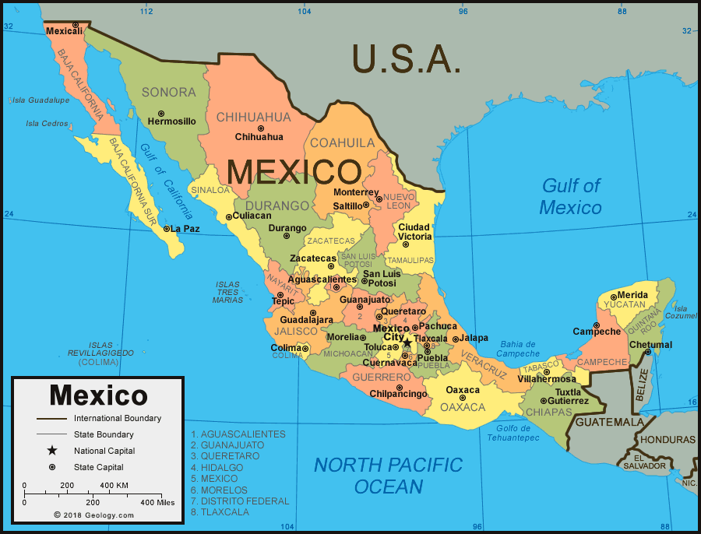

**Coordinates of Mexican States**

<https://geokeo.com/database/state/mx/1/>

In file folder.

**Time Series Dataset of Temperature per Latitude and Longitude**

<https://www.ncei.noaa.gov/access/monitoring/climate-at-a-glance/global/time-series>

**RCP 8.5**

<https://www.nccs.nasa.gov/services/data-collections/land-based-products/nex-gddp>

<https://sos.noaa.gov/catalog/datasets/climate-model-temperature-change-rcp-85-2006-2100/>

Readings

<https://link.springer.com/article/10.1007/s10584-011-0149-y>

**CM3 with RCP 8.5**

<https://www.gfdl.noaa.gov/coupled-physical-model-cm3/>